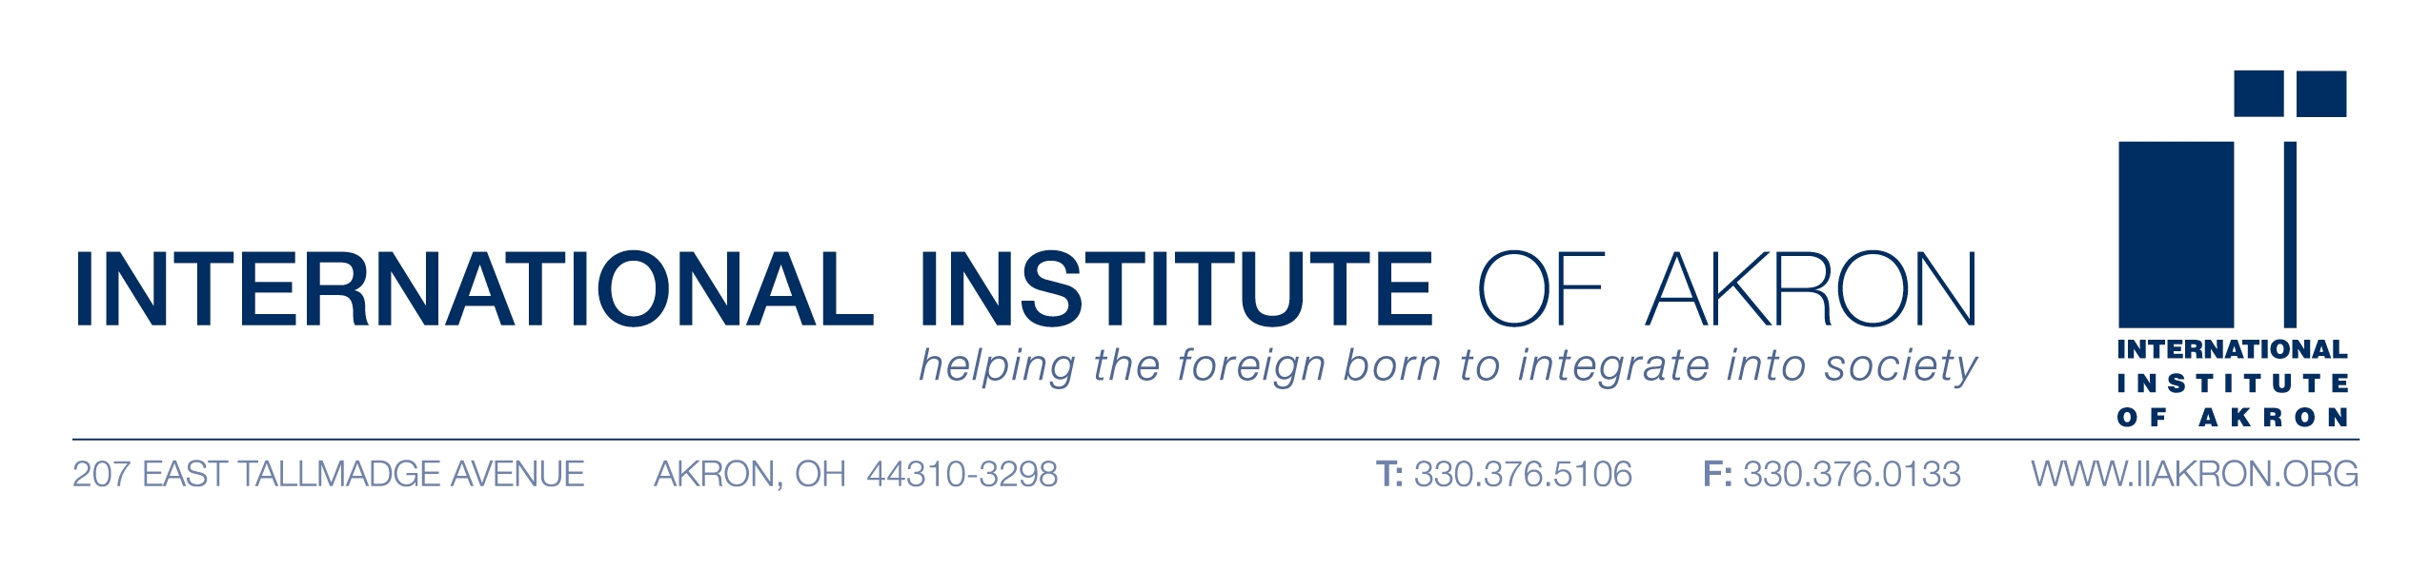
July 22, 2009
PRESS RELEASE
FOR IMMEDIATE RELEASE
CONTACT: Shelly Durbin, Director of PR and Development-- 330-376-5106, Ext. 26
International Institute of Akron to Hold One World, Many Cultures Event & Auction
Akron, Ohio: The International Institute of Akron (IIA) will hold its annual fundraising event and auction, “One World, Many Cultures” on Friday, August 28, 2009 at the Komodo Kingdom Center at the Akron Zoo, 500 Edgewood Avenue in Akron. Doors will open at 6:30 p.m.
Entertainment will include performances by Indian and African dance groups, as well as ethnic music. Tickets are $100 per person which includes international gourmet cuisine provided by Moe’s Catering and access to the zoo grounds. Auction items include multiple airline tickets, a condo stay in Florida, an oriental rug, luxury hotel packages, gift baskets, restaurant gift cards, artwork, and more.
Master of Ceremonies is Madeline Bozzelli. The event will honor the IIA Women’s Auxiliary Board, a group of women who have provided volunteer service to the agency for over 50 years.
Proceeds from the event will benefit the many programs and services of the International Institute. Sponsors for the event include Goodyear, Cohen & Company, GOJO, National City Bank, Conte & Company, and Akron Children’s Hospital.
Committee members include Shelly Durbin, Veronica Barnel, Debbie May-Johnson, Nancy Marmaduke, Julie Du and Norma Wilmoth.
The International Institute of Akron is a 93 year old non-profit agency that provides programs and services to help the foreign born to integrate into society, promote public awareness of the value of the ethnic diversity and encourage international communication. Programs include refugee resettlement, immigration counseling, citizenship preparation, English education, foreign language classes, translating and interpreting, youth programs and financial literacy. The agency serves over 5,500 individuals each year.
Reservations are encouraged. For more information about this event, sponsorship information, or to reserve tickets, call 330-376-5106 or visit the agency website at www.iiakron.org.
- END –
The International Institute of Akron is a non-profit organization that has been serving the needs of the foreign-born in the Greater Akron community since 1916. The IIA holds a 501c3 tax exempt status issued by the Internal Revenue Service and is funded by the United Way of Summit County, federal, state, foundation grants and the generous contributions of members and friends.

